h |  | Chapter 5
Employee Involvement

Contents
Chapter Purpose/Objectives 1
Class Discussion Guide 2
End-of-Chapter Self-Check 14
In-Class Activity: Conducting a Job Safety Observation 15
In-Class Activity: Completing a Job Safety Analysis 16
End-of-Chapter Self-Check Answer Key 17
Sample Completed JSA Form 19

Chapter 5
Employee Involvement

Chapter Purpose
The purpose of this chapter is to introduce you to employee involvement strategies that promote safety and health in the workplace. The chapter introduces strategies that include job safety analysis, job safety observation, safety contacts, safety inspections, safety and health committees, perception surveys, suggestion systems, and employee safety training. In addition, it presents methods and techniques that can help you more effectively carry out your roles and responsibilities as a supervisor.

Objectives
- Recognize the benefits of employee involvement in safety and health efforts.
- Describe the steps of a job safety analysis.
- Describe how to use a job safety analysis as the basis for job safety observations and safety contacts.
- Describe additional strategies for promoting safety and health through employee involvement.
- Identify ways to overcome barriers and challenges to employee involvement in safety and health efforts.
- Define roles and responsibilities in supporting employee involvement based on facility expectations for a supervisor.
Class Discussion Guide
Instructions: Follow along with the discussion using this outline of the key points. When you come to a question or chart with blank boxes in it, write your response in the space provided.

1. Recognize the benefits of employee involvement in safety and health efforts.
- E mployee involvement is an essential building block of any workplace safety and health program.
- All employees need to understand their responsibility for their own safety and for the safety of their co-workers.
Individual Activity: Place a check next to the employee involvement requirements you believe are met at this facility.
❑ | Frequent, visible demonstration of management’s commitment to safety
❑ | Training in the areas of safety and health
❑ | Opportunities for employees to get involved and have an influence on safety policies and practices
❑ | Constant and varied communication about safety
❑ | Recognition, reinforcement, and rewards for demonstrating safe behaviors
❑ | Appropriate employee involvement strategies, such as job safety analysis, safety and health committees, and others
- Three main benefits of getting employees involved in an organization’s safety and health efforts are:
- Increased productivity
- Safety compliance
- Incident reduction
Individual Activity: List any additional benefits you have seen from getting employees involved in safety efforts at this facility.

- Some typical supervisor responsibilities in the area of employee involvement are:
- Solicit employees to join employee involvement activities.
- Train employees so they can participate in these activities.
- Lead employee involvement activities.
Individual Activity: List one or two more roles or responsibilities you think a supervisor might have with respect to employee involvement.

2. Describe the steps of a job safety analysis (JSA).
- A JSA:
- Is a process used to identify hazards in the workplace before they occur
- Is often led by a supervisor
- Relies on the expertise of the people who perform a particular task by asking them to help identify:
  - The steps involved in performing the task
  - The existing or potential safety and health hazards related to each step
  - Recommendations for eliminating or minimizing the hazards
- Produces a written document that can serve as the basis for improving safety in the work environment and for training others
- There are four basic steps to conducting a JSA:
- Step 1: Select a task by taking the following into consideration:
  - Probability of incidents
  - Rate of disabling injuries
  - Severity potential
  - Number of employees exposed to the hazard
- Step 2: Break down the task into steps.
  - Observe an experienced worker perform the task.
  - Record the steps for performing the task.
  - Note any deviations from the standard operating procedure.
  - Get feedback to make sure you have included all of the steps in the right order.
  - List job steps on the JSA form.
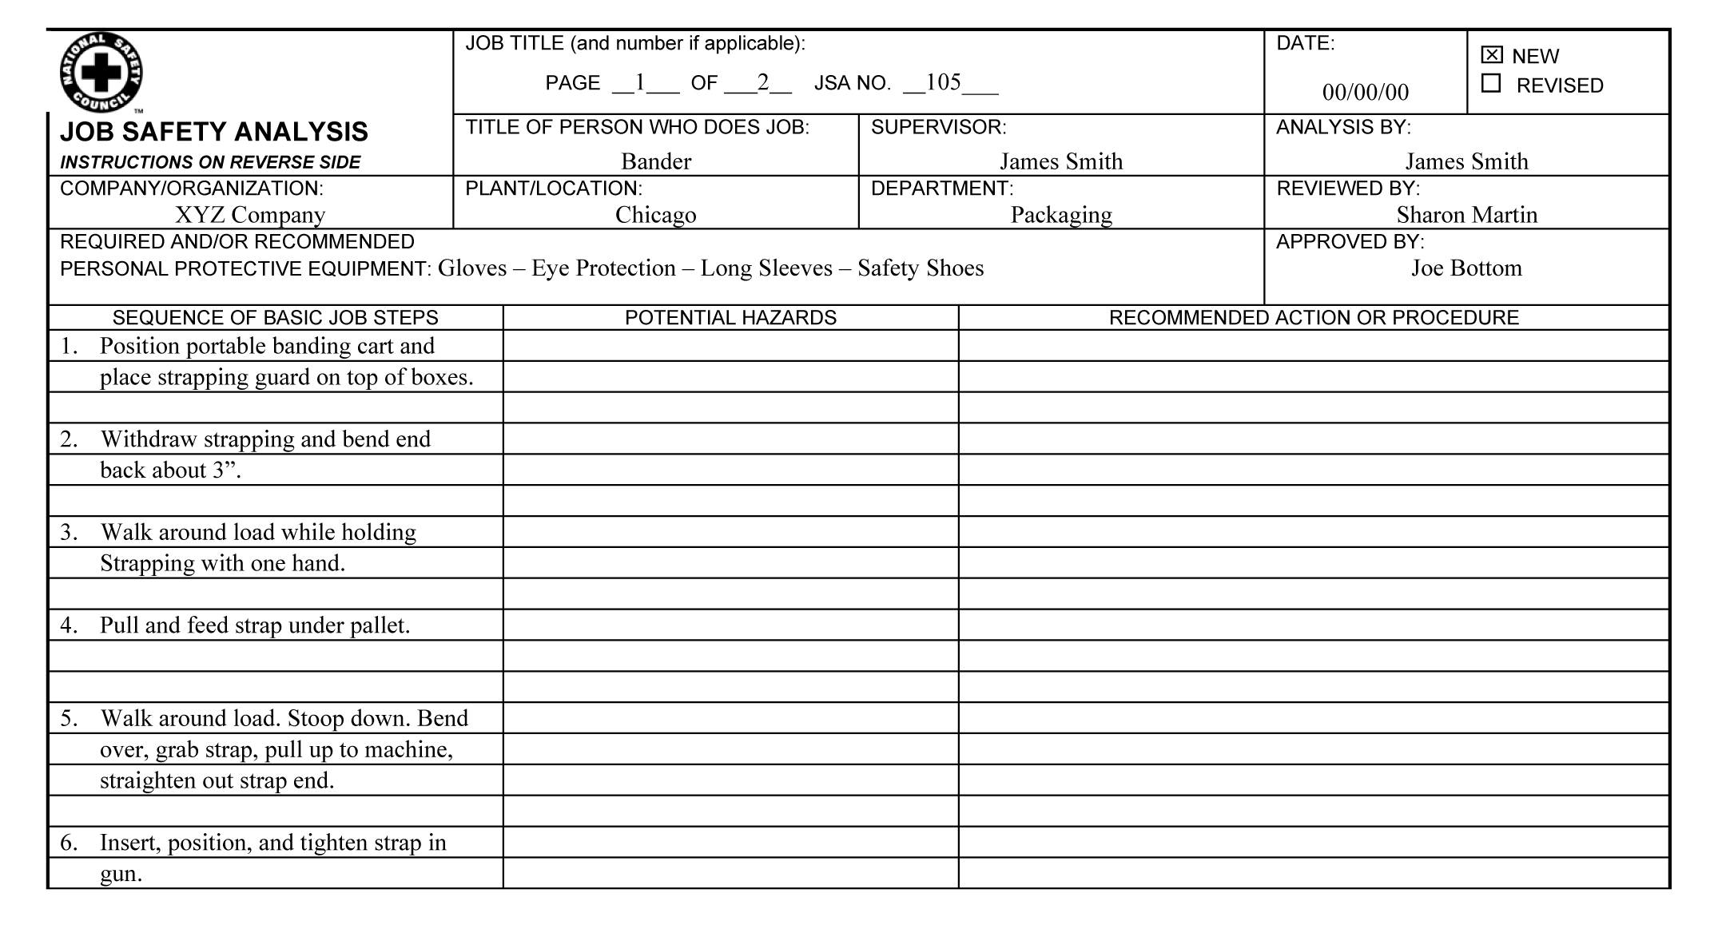
- Step 3: Identify potential hazards.
  - Ask questions for each step in the task:
What chemical hazards are associated with each step? What can be inhaled or absorbed through the skin? What can be ingested or have a corrosive effect?
What physical hazards are associated with the step? Consider things such as electricity, fire or explosion, noise, thermal stress, radiation, struck by or struck against injuries, and slips, trips and falls.
What are the biological hazards associated with each step? Consider blood and other potentially infectious fluids, animal waste or pests, plant toxins, or mold.
What are the ergonomic issues associated with each step? Consider repetition, awkward posture, forceful exertions, contact stress, or work area design.
  - List hazards identified on the JSA form.
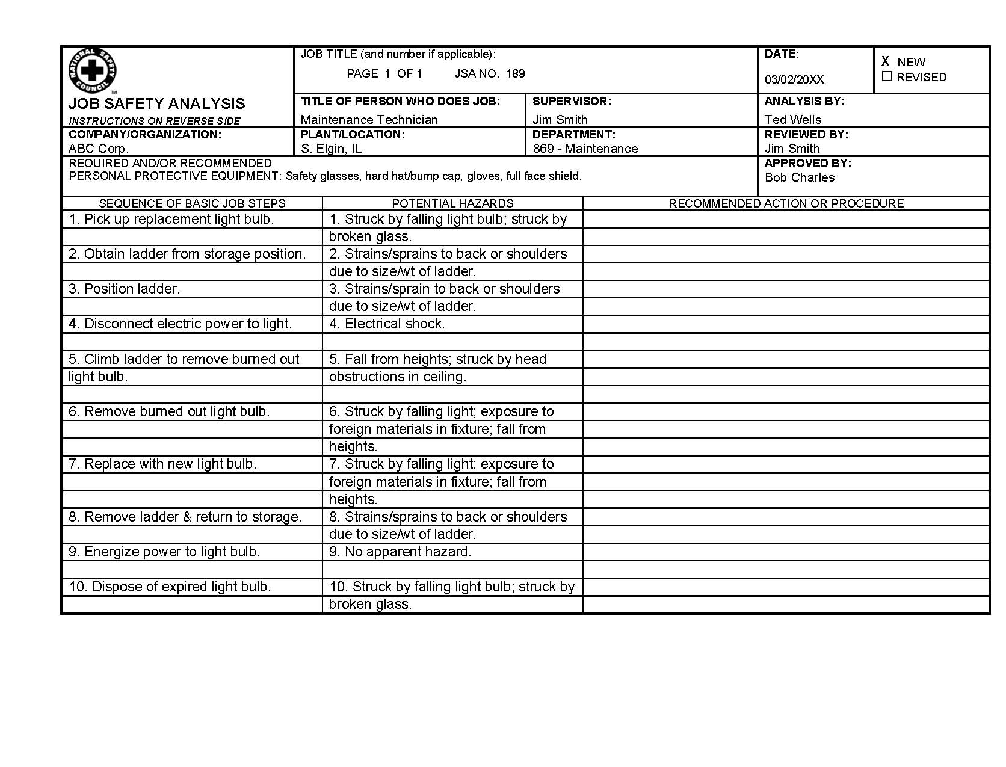

- Step 4: Develop safe job procedures to eliminate hazards and prevent potential incidents.
  - Types of solutions include:
Use engineering controls to eliminate the hazard.
Use administrative controls to minimize exposure to the hazard.
As a last resort, use personal protective equipment to provide a barrier between the employee and the hazard.
  - Check or test the proposed changes in procedure with workers who do the job or are affected by the changes.
  - Complete the JSA form by listing the solutions.
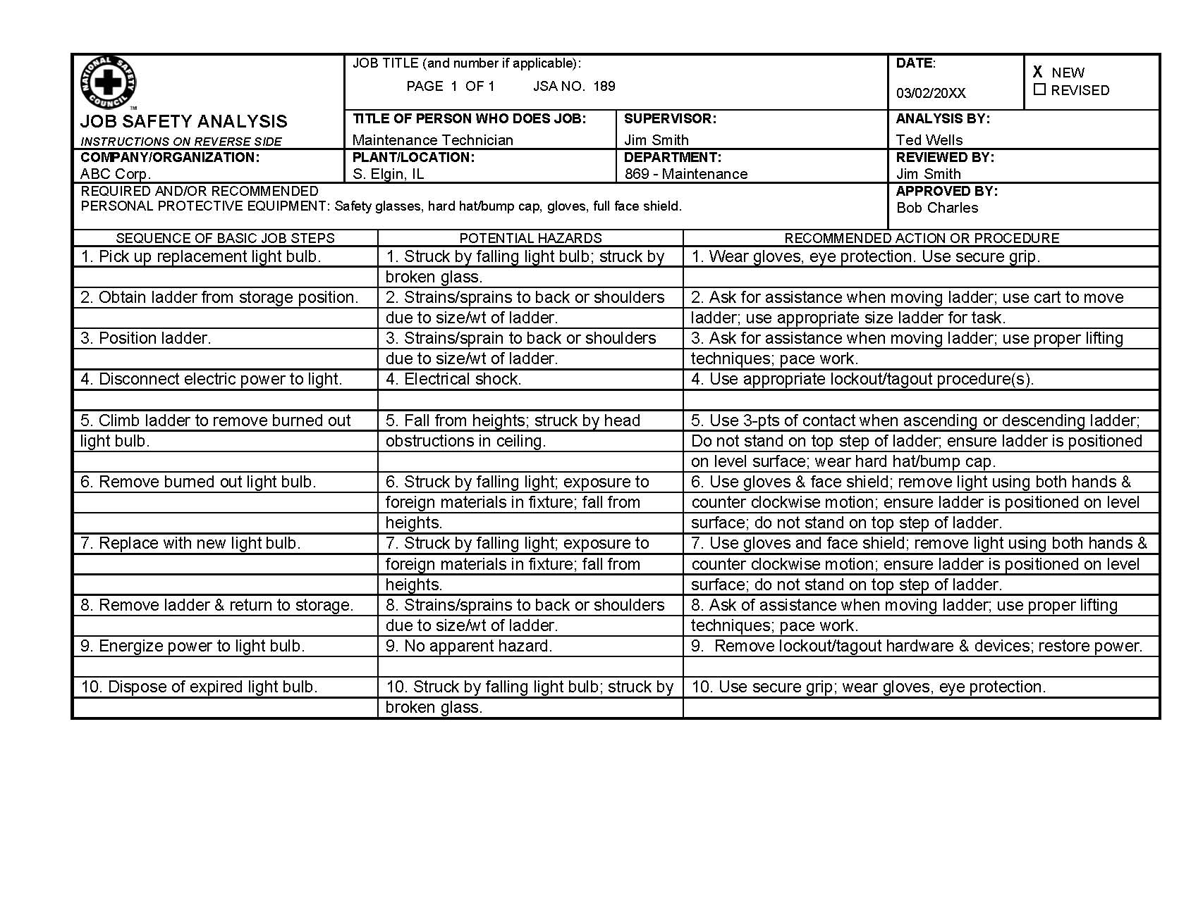
The benefit of doing a JSA is an overall increase in safety in the workplace.
- A completed JSA form:
- Documents job procedures
- Serves as a tool for use in training
- Provides useful information to use when making improvements to work methods
- The results of performing a JSA can serve these purposes:
- Form the basis for a job safety observation—a formal, planned audit of how things are actually being done on the job
- Act as a guide for employee safety contacts—safety-related discussions between a supervisor and an employee
- Describe how to use a job safety analysis as the basis for job safety observations and safety contacts.
- Purpose of a job safety observation: To see if a task is actually being done as it is described in the JSA documentation
- Steps in performing a job safety observation:
- Review the JSA for a particular task.
- Identify two or three critical behaviors.
- Observe these behaviors as employees perform the task.
- Give appropriate feedback.
- Tips for giving appropriate feedback:
- Give feedback as soon as possible after the observation.
- Start with praise.
- Avoid accusing.
- Develop solutions, as necessary, based on employee input.
Individual Activity: Answer the following questions about job safety observations.
Which routine tasks in my area could be improved through regular job safety observations?
What are two or three at-risk behaviors that could be eliminated through routine job safety observations?
- Safety contacts:
- Offer an informal approach to getting the same type of information gained through more formal job safety observations
- Are one-on-one safety-related meetings or discussions between a supervisor and an employee.
- Take place after a supervisor observes an employee at work
- As part of a safety contact, a supervisor:
- Recognizes and reinforces safe job performance
- Offers constructive criticism and further instruction as necessary
- During a safety contact, the employee can voice opinions regarding his or her own performance and company safety and health rules, procedures, and programs.
- Describe additional strategies for promoting safety and health through employee involvement.
- Safety and health committees
- Having employees serve on safety and health committees is an effective way to develop awareness and acceptance of company safety and health goals.
- The committee’s purpose should be clearly defined and may be:
  - Broad—such as being the ongoing decision-making process by which safety improvements are chosen and implemented in a facility
  - Narrow—such as resolving a specific safety issue or focusing on a specific safety need such as emergency response
- The employees who serve on a committee should have the skills needed to fulfill the committee’s defined purpose.
- Safety and health meetings
- Regular meetings may take the place of formal safety and health committees in some companies.
- Tips for conducting successful safety and health meetings are:
  - Use an agenda.
  - Preview visual aids and check equipment.
  - Select a comfortable, distraction-free meeting place.
  - Cover no more than three main ideas.
  - Limit meeting length to 60 minutes.
  - Circulate the agenda in advance to allow participants time to prepare for discussion.
  - Allow time for feedback and questions.
- Safety and health inspections:
- Help employees learn how to recognize hazards in the workplace
- Give employees a sense of “buy-in” by being part of the process
- Increase employees’ understanding of why inspections are important
- Perception surveys are a way to give employees an opportunity to anonymously voice attitudes about the organization’s safety and health program and perception of management’s commitment to safety.
- Suggestion system tips:
- Make submitting suggestions easy.
- Acknowledge suggestions promptly.
- Be fair and impartial.
- Publicize and reward useful suggestions.
- Allow for anonymous suggestions.
- Provide protection from retaliation.
- Safety and health training:
- Provides skills and knowledge to help employees perform their jobs safely
- Can benefit employees off the job as well as on
- Should include emergency procedures, such first aid and disaster plans
- Will transfer from the classroom to the workplace if the supervisor requires employees to apply what they have learned in training on the job
Individual Activity: Mark the strategies you have used at this facility with a check and describe how effective each strategy has been.
Employee Involvement Strategies | Used Here | Effectiveness of the Strategy
Safety and health committees | ❑
Safety and health meetings | ❑
Safety and health inspections | ❑
Perception surveys | ❑
Suggestion systems | ❑
Safety and health training | ❑
- Identify ways to overcome barriers and challenges to employee involvement in safety and health efforts.
Getting employees involved in safety efforts in a meaningful way is not always an easy task due to barriers and challenges that can get in the way.
Pairs Activity: Work with a partner to select three of the barriers/challenges from the following list and identify ways to overcome them.
Barriers and Challenges to Employee Involvement:
- Fear or lack of trust
- Amount of time and effort involved
- Uncertainty brought on by constant change
- Not involving key stakeholders
- Not involving unions (forming a partnership)
- Lack of demonstrated commitment or responsibility from top leadership
- Not allowing enough time to change
- Resistance from any of the partners (supervisors, managers, support people, unions, labor force)
- Inadequate training
- Systems and structures not designed to support teams
- Workers who focus in on their co-worker’s imperfections
- Failure to redefine the role of leadership
- Leaders who won’t let go
- Too little or too much structure
- No transition plan
- Failure to communicate what’s happening
- Treating change like a program instead of a process
- A history not conducive to employee involvement
Barrier/Challenge | Way to Overcome
- To overcome barriers or challenges to employee involvement, we must:
- Engage three groups of people
  - Our supporters—Look for ways to continually keep these employees engaged.
  - Those who oppose our safety efforts—Listen to them to determine if they have legitimate concerns.
  - Those who feel neutral toward safety—Look for ways to reward and support these employees and, in time, convert them to supporters.
- Focus most of our efforts on the 80% of employees who tend to either support safety or feel neutral toward it
- Define roles and responsibilities in supporting employee involvement based on facility expectations for a supervisor.

End-of-Chapter Self-Check

Instructions
Answer the following questions to assess your knowledge of the chapter. Then turn to the end of the chapter to check your answers.

Circle T if the statement is True or F if the statement is False.

1. T F An essential building block of any workplace safety and health program is employee involvement.

2. T F A job safety analysis forms the basis for job safety observations and safety contacts.

Circle the best answer.

3. Which of the following can an organization hope to gain from increasing employee involvement in its safety and health efforts?
A. Increased productivity.
B. Safety compliance.
C. Incident reduction.
D. All of the above.

4. Job safety observations are most effective when they:
A. Criticize an employee’s behavior.
B. Last for one to two hours.
C. Acknowledge the good before correcting any at-risk behaviors.
D. Are informal and unstructured.

5. Which of the following can be a barrier to getting employees involved in an organization’s safety and health efforts?
A. Fear or lack of trust.
B. Lack of demonstrated commitment or responsibility from top leadership.
C. Inadequate training.
D. All of the above.

In-Class Activity:
Conducting a Job Safety Observation

Objective
To complete a job safety observation using a scenario based on the job safety analysis example in this chapter or a workplace scenario of your own choosing

Instructions
Read all of the following instructions carefully before beginning the exercise.
- Your facilitator will assign you to take on one of three roles in a role-play activity: supervisor, observer, or observed employee.
- Follow the instructions for your assigned role.
- Supervisors: Review the information on page 8 that describes the steps in completing a job safety observation. You will apply those steps to the workplace scenario the facilitator describes to you.
- Observers: Review the information on page 8 that describes the steps in completing a job safety observation. You will watch the role play and afterward give feedback on what the supervisor did well and suggestions for how the supervisor could have responded differently.
- Employees: Listen carefully to the scenario as it is described. You will be given some additional instructions from the facilitator.
Part III: In-Class Activity
Completing a Job Safety Analysis

Objective
To gain experience creating a job safety analysis using the information presented in this chapter

Instructions
Read all of the instructions thoroughly before beginning the exercise.
- Form small groups.
- Work together to select a topic for a job safety analysis that your group will complete and submit to the facilitator.
- Use the information about job safety analysis presented in this chapter to plan and conduct a JSA on the task you have chosen. Also, refer to the example of a completed JSA form at the back of this chapter.
- At the next meeting, be prepared to present the completed JSA to the group.
End-of-Chapter Self-Check Answer Key

1. T F An essential building block of any workplace safety and health program is employee involvement.

2. T F A job safety analysis forms the basis for job safety observations and safety contacts.

3. Which of the following can an organization hope to gain from increasing employee involvement in its safety and health efforts?
A. Increased productivity.
B. Safety compliance.
C. Incident reduction.
D. All of the above.

4. Job safety observations are most effective when they:
A. Criticize an employee’s behavior.
B. Last for one to two hours.
C. Acknowledge the good before correcting any at-risk behaviors.
D. Are informal and unstructured.

5. Which of the following can be a barrier to getting employees involved in an organization’s safety and health efforts?
A. Fear or lack of trust.
B. Lack of demonstrated commitment or responsibility from top leadership.
C. Inadequate training.
D. All of the above.



