National Safety Council Member Appreciation Month

January is Member Appreciation Month at the National Safety Council. We are paying tribute to your #SafetyHeroes and also expressing gratitude for your continued support to help make people’s lives safer from the workplace to anyplace.

Sample Social Media Copy

1) Use the suggested post copy below, or simply use the copy as inspiration to create your own posts.
2) An image is available for download (link). Save the asset where it’s readily available, and upload directly in your social post.
3) Be sure to tag the National Safety Council in your posts. Type out and select ‘@National Safety Council’ in Facebook and LinkedIn posts for proper tagging. You can also share messages from the National Safety Council social media pages by clicking ‘share’ in each platform.

Image | Text for Facebook/LinkedIn  (don’t forget to tag NSC by typing and selecting @National Safety Council) | Text for Twitter
 | In January, the @NationalSafetyCouncil is observing its Member Appreciation Month, and I am saluting my #SafetyHero, (name). Thank you for all you do to #KeepEachOtherSafe. | In January, @NSCSafety is observing its Member Appreciation Month, and I am saluting my #SafetyHero, (name). Thank you for all you do to #KeepEachOtherSafe.
 | Being a member of the @NationalSafetyCouncil is about working together to be safe, and I am honoring my #SafetyHero, (name). Thank you for your work to #KeepEachOtherSafe during these challenging times. | Being a member of @NSCSafety is about working together to be safe, and I am honoring my #SafetyHero, (name). Thank you for your work to #KeepEachOtherSafe during these challenging times.
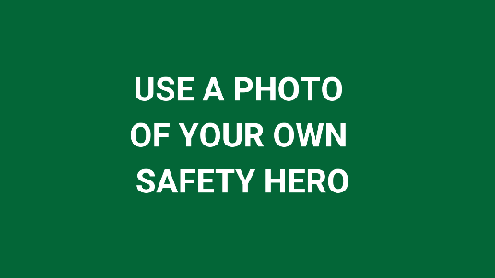 | Being a member of the @NationalSafetyCouncil is about working together to be safe, and I am honoring my #SafetyHero, (name). Thank you for your work to #KeepEachOtherSafe during these challenging times. | Being a member of @NSCSafety is about working together to be safe, and I am honoring my #SafetyHero, (name). Thank you for your work to #KeepEachOtherSafe during these challenging times.
 | NSC will post the Member Appreciation Video on its social media platforms on Monday, January 11. Head there to share the posts:  Facebook: www.facebook.com/NatlSafetyCouncil  LinkedIn: www.linkedin.com/company/national-safety-council | NSC will post the Member Appreciation Video on its social media platforms on Monday, January 11. Head there to retweet the post:  Twitter: www.twitter.com/NSCsafety

Facebook Frame Instructions:
Option 1: Change it on your Facebook page
Step 1: Go to your own Facebook profile. Find your profile page by clicking on your icon in the top left corner of your news feed.
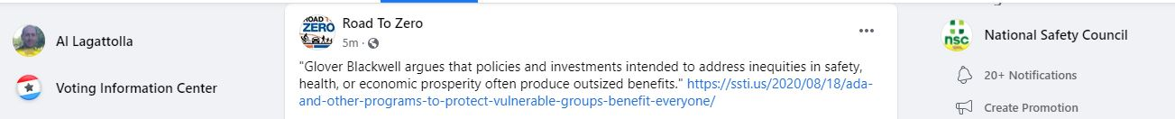

Step 2: Click the camera icon on your profile photo and then select “Update Profile Picture"
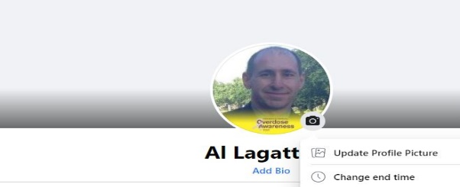
Step 3: Once you click “Update,” a box should appear with photos. Look at the top of the auto-populate box and select “Add Frame.”
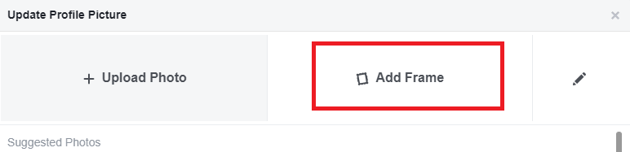
Step 4: Type “2021 Member Appreciation Month” in the search field in the top left corner, and the frame should appear. Select that frame and crop your profile filter however you see fit. You can decide how long you want to use the frame, then click “Use as Profile Picture.”

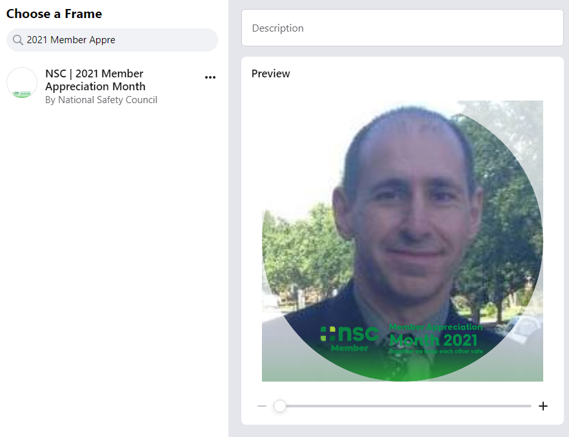

Option 2: Straight from the NSC Post
  - NSC will publish a post on January 1 highlighting the filter and announcing the start of Membership Appreciation Month. On the post, click the photo, and you'll see an area that invites you to "Change Your Profile Picture." Select the Facebook Frame - or search for it - then click "Use as Profile Picture."

Questions? Contact Al.Lagattolla@nsc.org.

