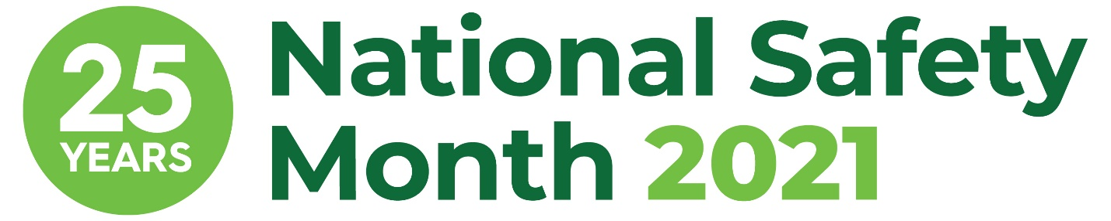

NSM Week 2 Sample Email Copy

[Subject] Join [COMPANY NAME] this June for National Safety Month

[Body]
Hello [NAME],
I am proud to share that [COMPANY NAME] is taking part in the 25th anniversary of National Safety Month, taking place throughout June 2021. This annual observance, led by the National Safety Council, highlights pressing weekly topics and encourages everyone to prioritize safety from the workplace to anyplace.

The second week of June will focus on addressing ongoing COVID-19 safety concerns. The pandemic has had a dramatic impact on the way we work, highlighting the importance of strong safety practices for every role. It continues to pose challenges, but we remain committed to working with NSC to address them.
At [COMPANY NAME], we believe workplace safety is more important than ever. [COMPANY NAME] is excited to participate in this important observance by [SHARE DETAILS ON HOW YOU ARE PARTICIPATING].
Please join us in prioritizing safety from the workplace to anyplace. Visit nsc.org/nsm to learn more about National Safety Month.
Sincerely,
[YOUR NAME AND COMPANY SIGNATURE BLOCK]

