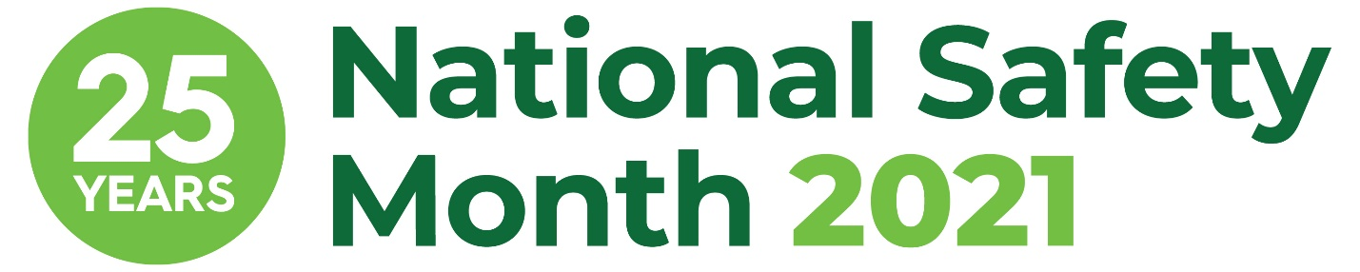

NSM Week 3 Sample Email Copy

[Subject] Join [COMPANY NAME] this June for National Safety Month

[Body]
Hello [NAME],
I am proud to share that [COMPANY NAME] is taking part in the 25th anniversary of National Safety Month, taking place throughout June 2021. This annual observance, led by the National Safety Council, highlights pressing weekly topics and encourages everyone to prioritize safety from the workplace to anyplace.

The third week of June will focus on why it is so vital to feel safe on the job, both physically and psychologically. The more comfortable you feel being yourself at work without worrying about retaliation, the more you can focus on keeping yourself and your co-workers safe. This includes everything from stress and mental health concerns to diversity equity and inclusion. Never be afraid to speak up or ask for help if you feel uncomfortable or not like yourself.

At [COMPANY NAME], we believe strong mental health is crucial to a safe workplace. [COMPANY NAME] is excited to participate in this important observance by [SHARE DETAILS ON HOW YOU ARE PARTICIPATING].
Please join us in prioritizing safety at work so we can all live our fullest lives. Visit nsc.org/nsm to learn more about National Safety Month.
Sincerely,
[YOUR NAME AND COMPANY SIGNATURE BLOCK]

