FUNDAMENTALS OF INDUSTRIAL HYGIENE, 6TH ED.

HOMEWORK #5
INDIVIDUAL MEASUREMENT OF SOUND – SPREADSHEET DEVELOPMENT

Objective: Students will become familiar with the use of Excel spreadsheets through the development and formatting of tables that can be used for calculating sound power levels and sound pressure levels. Specific techniques will include the formatting of cells and cell contents, use of formulas, and linking of cell values/formulas.

Part I: Spreadsheet Basis
Using the Sound Calculations tab on the spreadsheet provided, create tables based on the examples provided on the following pages. The top table on the spreadsheet will be developed for calculating sound power levels, and the bottom table on the spreadsheet will be developed for calculating sound pressure levels.

Format all cell contents as they appear in the examples provided (i.e., bold-face, italicize, subscript, alignment). Ensure all text is in the specific cell as identified on the examples provided.
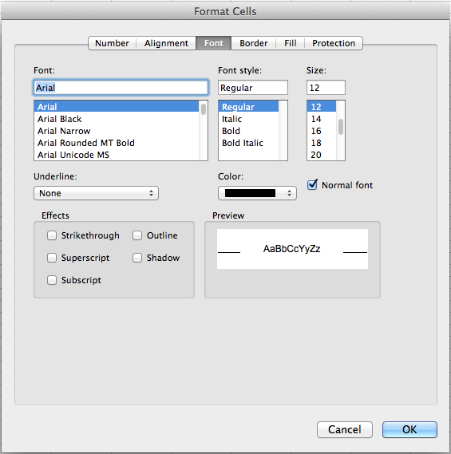
Base Font: Arial, 12-point

How to subscript text:
• Type text into cell.
• Highlight that portion of the text you want to subscript.
• Click on “Format” in the Excel menu at the top of the screen, and select “Cells” from the options.
• Check the ‘Subscript’ option in the dialogue box that opens.

How to insert symbols (e.g., • , ÷):
• Place the insertion bar where you want the symbol to appear
• Click on “Insert” in the Excel menu at the top of the screen, and select “Symbol…” from the options.
• Scroll through the options to find the desired symbol, and then click on it to insert it into the text.
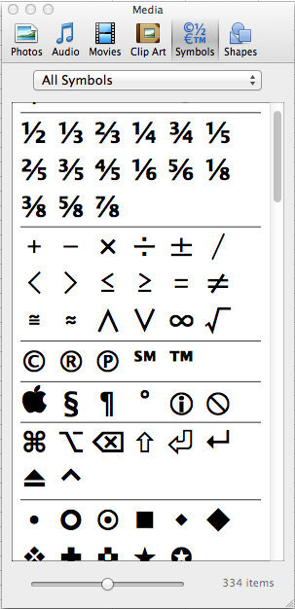
How to format numbers:
• Type number into cell.
Depending on how Excel is set up on your computer, the number may appear in a variety of different ways (e.g., scientific notation – 1E-13).
• Click on the cell, and then use the “Number” formatting tool in the ribbon to change the format to “Number”.
• To change the number of decimal places that show, use the “decimal point” option.
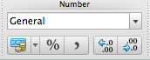

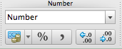
How to adjust column widths:
• Cell widths can be adjusted manually, or automatically.
• For this exercise, use the automatic function: “Format”, “Column”, “AutoFit Selection” as follows:
column B: width of value in cell B:62
column C: width of value in cell C:27
column D: width of value in cell D:6
column E: width of value in cell E:39
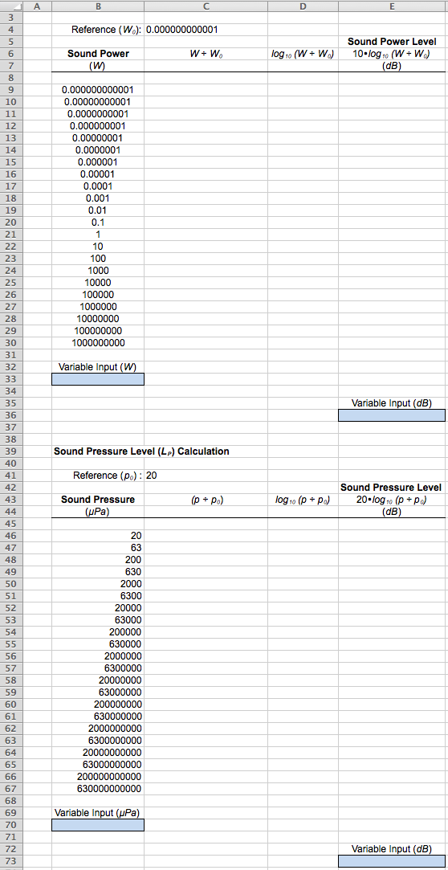
Part II: Sound Power Table Formulas
Enter the formulas identified in the example (see page after the next) into the Sound Power Level spreadsheet table you have created.

Formula 1: Cell C:9
This formula will conduct the division operation in the sound power formula:
$$L_{W} = 10 • \log_{10}\left(\frac{W}{W_{0}}\right)$$

In the first formula cell (C:9) of the column, the sound power value found in cell B:9 must be divided by the sound power reference value, which is found in cell C:4.
Entering the formula as: =B9/C4 would not be incorrect; however, this formula will be copied into all other cells in this column (C:10 – C:30).
If copied and pasted as =B9/C4, both row values would be increased by one (1) in each succeeding row.
Thus, the formula in cell C:10 would read: =C10/C5, and the formula in cell C:11 would read: =C11/C6, and all of the calculations would be off.
Go ahead and give it a try: type the formula: =B9/C4 into cell C:9, copy and paste it into cells C:10 – C:30, and then go into those cells and see how the formula has been copied.

To prevent this from happening, the cell containing the sound power reference value (C:4) must be “locked” to prevent it from changing.
This is accomplished by inserting a dollar sign ($) in front of the column letter and in front of the row number: =B9/$C$4.
Now, when the formula is copied and pasted, only the sound power cell is changed, which will always be divided by the value in cell C:4 (the sound power reference value).

Formula 2: Cell D:9
This formula will conduct the log operation in the sound power formula:
$$L_{W} = 10 • \log_{10}\left(\frac{W}{W_{0}}\right)$$

In the first formula cell (D:9) of the column, the log of the quotient of the division operation found in cell C:9 must be calculated.
In this case, the formula can be entered as just: =LOG(C9), since when it gets copied to all other cells in the column (D:10 – D:30), the cell that is “logged” will always be correct.

Formula 3: Cell E:9
This formula will conduct the multiplication operation in the sound power formula:
$$L_{W} = 10 • \log_{10}\left(\frac{W}{W_{0}}\right)$$

In the first formula cell (E:9) of the column, the value of the previous operation found in cell D:9 must be multiplied by 10.
In this case, the formula can also be entered as just: =10*D9.

Note: After each formula has been entered into cells C:9, D:9, and E:9, they need to be copied and pasted into the remaining cells of each column.
Also, these formulas need to be copied into cells C:33, D:33, and E:33.

Note: The column width for column H may need to be reset to accommodate the width of the value in cell C:33.

Remaining Formulas:
The remaining formulas found in cells D:36, C:36, and B:36 reflect the inverse operations of the formulas just entered.
They are designed to allow the entry of a known sound power level (in dB), and “back-track” to its corresponding sound power.
Part III: Sound Pressure Table Formulas
Enter the formulas identified in the example (see following page) into the Sound Pressure Level spreadsheet table you have created.

Formula 1: Cell C:46
This formula will conduct the division operation in the sound pressure formula:
$$L_{P}= 20 • \log_{10} \left(\frac{p}{p_{0}}\right)$$

In the first formula cell (C:46) of the column, the sound pressure value found in cell B:46 must be divided by the sound pressure reference value, which is found in cell C:41.
For the reasons of enhancing cut-and-paste abilities discussed earlier, the sound pressure reference value cell will be “locked”: =B46/$C$41

Formula 2: Cell D:46
This formula will conduct the log operation in the sound pressure formula:
$$L_{P}= 20 • \log_{10} \left(\frac{p}{p_{0}}\right)$$

In the first formula cell (D:46) of the column, the log of the quotient of the division operation found in cell C:46 must be calculated.
In this case, the formula can be entered as just: =LOG(C46), since when it gets copied to all other cells in the column (D:47 – D:67), the cell that is “logged” will always be correct.

Formula 3: Cell E:46
This formula will conduct the multiplication operation in the sound pressure formula:
$$L_{P}= 20 • \log_{10} \left(\frac{p}{p_{0}}\right)$$

In the first formula cell (E:46) of the column, the value of the previous operation found in cell D:46 must be multiplied by 20.
In this case, the formula can also be entered as just: =20*D46.

Note: After each formula has been entered into cells C:46, D:46, and E:46, they need to be copied and pasted into the remaining cells of each column.
Also, these formulas need to be copied into cells C:70, D:70, and E:70.

Remaining Formulas:
The remaining formulas found in cells D:73, C:73, and B:73 reflect the inverse operations of the formulas just entered.
They are designed to allow the entry of a known sound pressure level (in dB), and “back-track” to its corresponding sound pressure.

Final Formatting:
Format the number display of cells B:33 and B:70 to “Scientific”.
This is because the actual value that will be entered into this cell cannot be anticipated.

Format the number display of cells B:36 and B:73 to “Scientific”.
This is because the actual value that will be entered into this cell cannot be anticipated.

Format the number display of cells E:33 and E:70 to display out to three decimal places.
This is because there is a wide range of values that may appear between 10-decibel level increments.

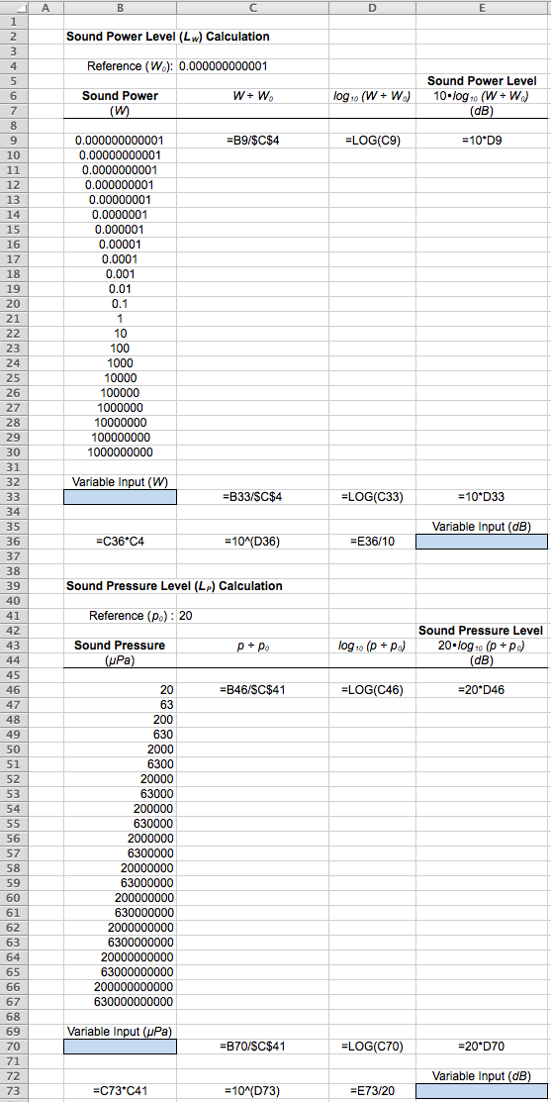
Part IV: Noise Survey and Noise Level Contours
Noise level contours can be used during a detailed noise survey of a job site to determine work stations that may pose particular noise-exposure hazards. Noise level contours can also be utilized to identify areas adjacent to job sites that may experience excessive noise levels during operations such as construction or demolition activities. Noise level contours provide a visual depiction of the degree of the noise hazard in a work area.

To construct a noise level contour:
• the work area is divided into evenly spaced grid lines; and
• A-weighted sound level measurements are recorded at each measurement position.
- when the observed sound levels vary significantly, the grid spacing should be decreased.
- it is usually necessary to decrease the grid spacing in the proximity of dominant noise sources due to rapidly changing sound levels.

The diagram on the following page depicts a wood-working shop with four pieces of power equipment: router table, cross-cut radial arm saw, table saw, and surface planer. Three work benches are also present for glue-up, assembly, and final finishing. A detailed noise survey was conducted based on a 2-foot grid during a period when all equipment was operating. The measured sound level is indicated in the center of each grid.

Sound contours are drawn based on equal-increment values. For this exercise, contours are desired to represent every whole 10 dB increment (i.e., 60 dB, 70 dB, 80 dB, 90 dB, and 100 dB). Since very few of the values on the diagram fall exactly on whole 10 dB increments, this effort will require the use of interpolation. Interpolation is the estimation of unknown values based on known values. Through the use of interpolation, the researcher assesses adjacent values to determine the placement of the contour line so that it best reflects the location of a desired value. For example, it is clear that the 100 dB contour line must run between each of the three sets of values below. However, interpolation suggests the line should be near the 99 dB point in the first diagram, further away but closer to the 99 dB point in the second diagram, and evenly spaced between the two values on the third diagram. This can be quite tedious, especially when just beginning.

99 Ι 108 99 Ι 105 99 Ι 101

The use of data recording devices and computer software has made this task much easier, by allowing the use of color-coding to depict the desired noise contour intervals. Even without the use of sophisticated and expensive data recorders and software applications, color-coding can be accomplished by utilizing one of the built-in functions of Excel: the conditional formatting option.

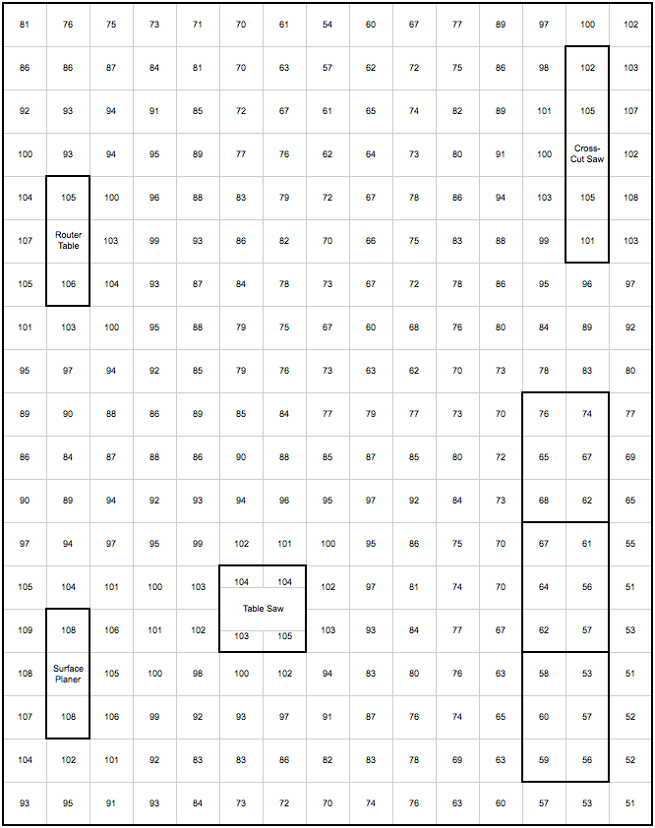
Instructions: Conditional Formatting of Cells
Open the Sound Contour tab on the spreadsheet provided.

Select (highlight) all cells in the diagram: B:2 – AE:39.
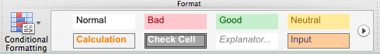
Click on the “Conditional Formatting” option in the “Format” section of the ribbon.

Select the “New Rule” option.
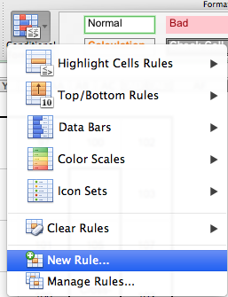

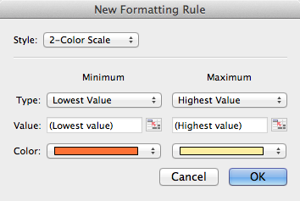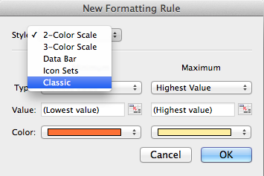
Under the “Style” pull-down menu, select “2-Color Scale”.

Under the next pull-down menu, select “Format only cells that contain”.
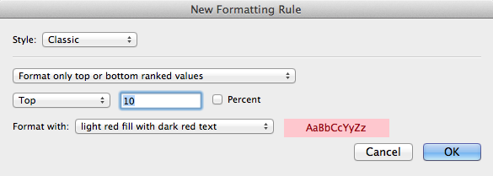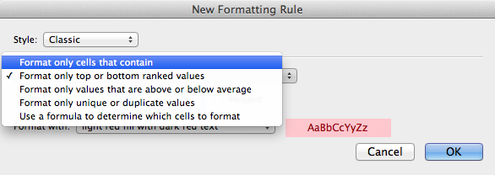

Change the “Specific text” option to “Cell value” using the pull-down menu.
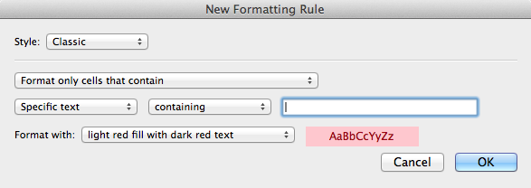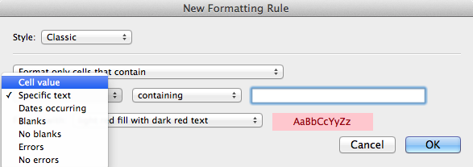

Notice that the next button has automatically changed to “between” and there are two spaces for data entry.
Enter the first range of values in the spaces provided. Start with the lowest range of values of interest in the diagram . . . “between” 50 and 59.
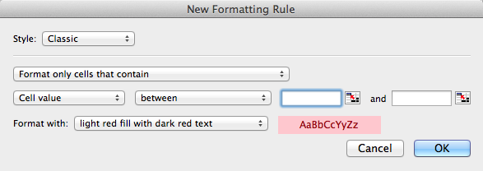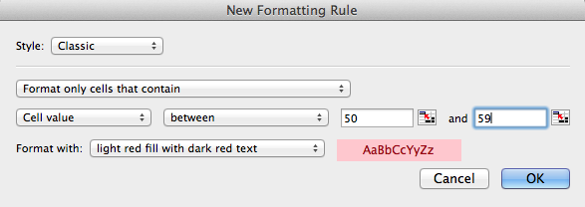

The final step is setting the appearance of the conditionally formatted cell.
Under the “Format with:” pull-down menu, select “custom format”.
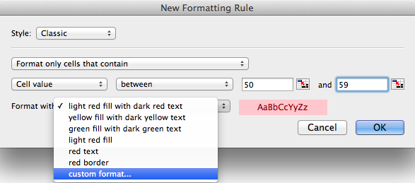

For the range of values from 50 - 59, set the cell fill to “purple”.
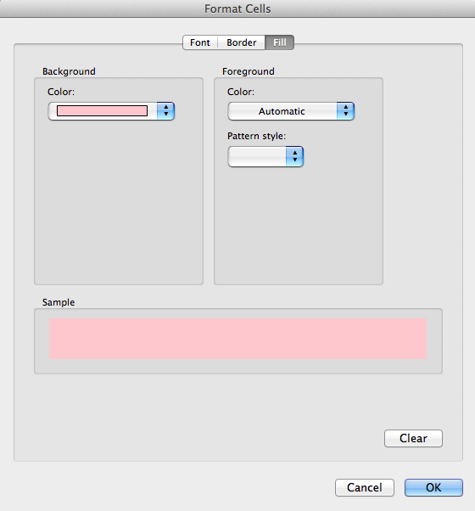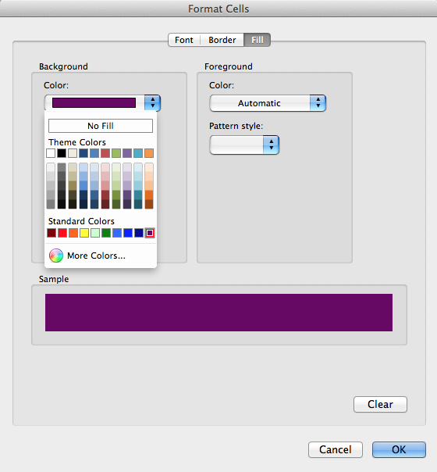

After setting the fill color, click on the “Font” button.
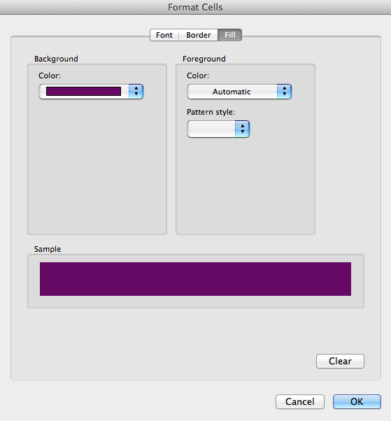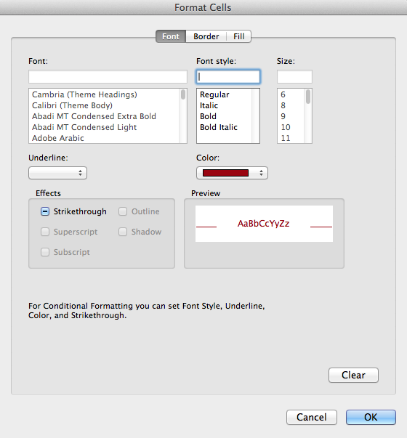

In the “Font style” menu, click on “Regular” and then set the font color to “white”.
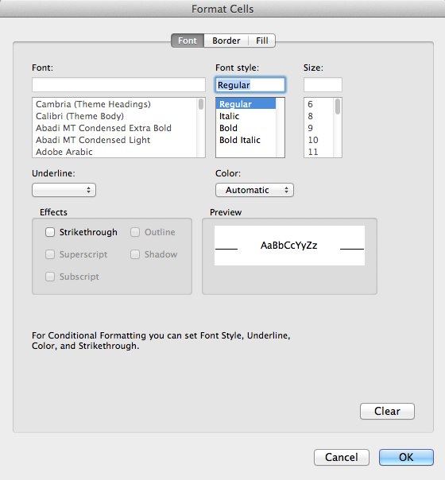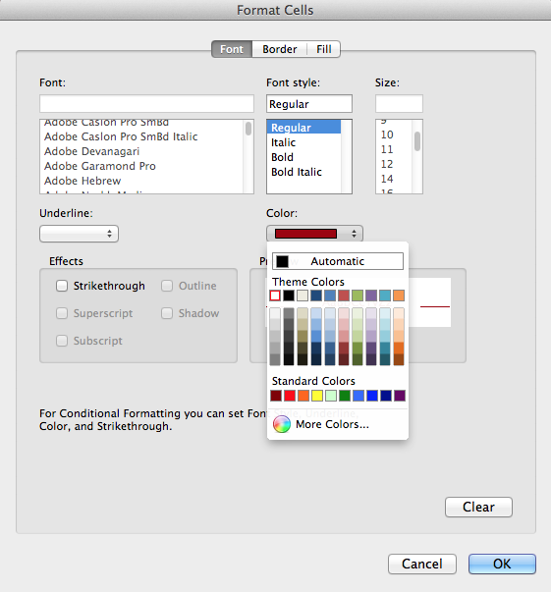

Create “new rules”, repeating the steps above for each of the other increments and using the following guidance:

data range fill color font color data range fill color font color
50 – 59 purple white 60 – 79 blue white
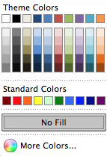

data range fill color font color data range fill color font color
70 – 79 green black 80 – 89 yellow black

data range fill color font color data range fill color font color
90 – 99 orange black 100 – 110 red black

FUNDAMENTALS OF INDUSTRIAL HYGIENE, 6TH ED.

HOMEWORK #5
INDIVIDUAL MEASUREMENT OF SOUND – SPREADSHEET DEVELOPMENT

Name:

EXERCISES: Perform the calculations identified below. Show your work neatly and clearly in a manner similar to the examples provided above (i.e., write the formula, define each variable in the formula, show steps of your calculations).

Part I: Sound Power Levels
Using your spreadsheet, find the corresponding sound power levels (in dB) given the following sound powers (round to the nearest whole number): (5 points)

0.09632 W = dB

0.9632 W = dB

9.632 W = dB

96.32 W = dB

963.2 W = dB

Notice that each of the values given represents a ten-fold increase in power output from the previous value.
What is the relationship in sound power (W) and sound power levels (in dB) based on your calculations? (1 point)

When the sound power is increased by a factor of 10, the sound power level increases by dB.

Part II: Sound Pressure Levels
Using your spreadsheet, find the corresponding sound power levels (in dB) given the following sound powers (round to the nearest whole number): (5 points)

467.34 μPa = dB

4673.4 μPa = dB

46734 μPa = dB

467340 μPa = dB

4673400 μPa = dB

Notice that each of the values given represents a ten-fold increase in sound pressure from the previous value.
What is the relationship in sound pressure (μPa) and sound pressure levels (in dB) based on your calculations? (1 point)

When the sound pressure is increased by a factor of 10, the sound pressure level increases by dB.

Part III: Variable Determination
Identify five pieces of equipment common to an industrial facility or construction site (e.g., vehicles, tools, machines, fans, pumps) and perform an on-line search for typical decibel level outputs for each.
Using your spreadsheet, determine the sound power and the sound pressure for each (round to two decimal places). (15 points)

equipment dB sound power sound pressure
(W) (μPa)
(scientific notation) (scientific notation)

Note: Print a copy of the Sound Power Level and Sound Pressure Level spreadsheet formatted to fit on one side of a standard 8.5 X 11 page.
Attach the printout to the back of this page for submittal.

Part IV: Noise Level Contours
This exercise will be submitted electronically along with the Sound Power Level and Sound Pressure Level spreadsheet. (36 points – see rubric)

Before saving your spreadsheet, please do the following:

• place the cursor in cell A:1 of each tab of the spreadsheet; and

• size the window so the entire work is visible.

Save your spreadsheet and then re-name it, using: First Initial, Last Name, HW5, SHM471.xlsx

(ex. BSmithHW5SHM471.xlsx) Note: no commas.

Attach the spreadsheet to an email addressed to your instructor: Sullivanall@cwu.edu

• in the Subject line, type: SHM 471 Homework #5

• include a salutation (e.g., Dr. Sullivan or Doc)

• include a brief note regarding the purpose of the email
(e.g., Attached, please find my Homework #5 exercise that is due on XXXXday.)

• include a complementary closing (e.g., Thanks, V/R (virtual regards when used in an email))

• include your name (e.g., Yosemite Delano, Y. Delano)

• make sure you attached the spreadsheet

• click on the “Send” button

SHM 471 – HOMEWORK #5
INDIVIDUAL
MEASUREMENT OF SOUND – SPREADSHEET DEVELOPMENT

Student Name:

Outcome: Students will demonstrate their ability to develop a functional sound measurement Excel spreadsheet.

Job Safety Analysis Assignment Rubric
 | PP | PE | Exceeded  Expectations  (6) | Meets Most  Expectations  (4) | Meets Some  Expectations  (2) | Did Not Meet  Expectations  (0)
Following  Guidelines | 6 |  | Followed assignment guidelines. | Followed most assignment guidelines. | Attempted to follow assignment guidelines. | Did not follow assignment guidelines.
Cell Content | 6 |  | There were no errors in spelling or text/number alignment. All numbers were properly formatted. All formulas were correct and appeared in all appropriate cells. | There were minor errors in spelling or text/number alignment. Most numbers were properly formatted. Most formulas were correct and present in most cells. | There were multiple errors in spelling or text/number alignment. There were multiple errors in number formatting. Incorrect formulas were entered or missing in multiple cells. | There were substantial errors in spelling or text/number alignment. Number formatting was not utilized. Formulas were not used.
Font | 6 |  | Fonts used were correct type, size, style, and color, and correct symbols were used. | There were minor errors in font type, size, style, or color, or in symbols used. | There were multiple errors in font type, size, style, or color, or in symbols used. | There were substantial errors in font type, size, style, or color, or in symbols used.
Cell Format | 6 |  | Cell widths, heights, merging, borders, and fill were correct. | There were minor errors in cell widths, heights, merging, borders, or fill. | There were multiple errors in cell widths, heights, merging, borders, or fill. | There were substantial errors in cell widths, heights, merging, borders, or fill.
Submission | 6 |  | Hardcopy submission was properly stapled and included this rubric as a cover page. Electronic submission included a subject line, message, file name, and was the correct file type. | Hardcopy submission was not stapled or did not include this rubric as a cover page. Electronic submission was lacking a subject line, message, file was misnamed or was of the wrong file type. | Hardcopy submission was not stapled or was missing this rubric. Electronic submission was lacking a subject line, message, file was misnamed or was of the wrong file type. | Hardcopy was not submitted. Electronic copy was not submitted.
Professionalism  and  Appearance | 6 |  | Final product is exemplary in all respects and exhibits attention to detail. | Final product is acceptable, but could be improved with some effort. | Final product contains some less-than-professional attributes. | Final product is sloppy and amateurish.
Score | 36 |  | Comments:
PP – Points Possible; PE – Points Earned

Your assignment must follow the general guidelines listed below. Please do not hesitate to contact me in my office or at sullivanall@cwu.edu if you have questions about these requirements or need further information. Failure to follow these guidelines may result in having your assignment refused and/or returned with only partial credit.

Guidelines

• Do not wait until the last minute to begin this assignment.
Waiting until shortly before the due date decreases your opportunities to ask questions regarding the assignment and clearly reduces the time you will have to proofread and polish your work.

• All assignments submitted for credit must be your original work . . . this is an individual assignment.
You may discuss the questions and any broad ideas with your classmates or others, but you must do the work yourself and turn in your own work.

• The first page of your assignment should list your name and include the rubric for the Measurement of Sound - Spreadsheet assignment.
Your assignment will be assessed using the rubric, hence, you are encouraged to utilize the rubric as you complete your assignment.

• You must staple all pages together in the upper left-hand corner.
Do this before coming to class . . . do not expect a stapler to be available in the classroom.
Unstapled assignments will not be accepted.

• Submit your assignments on time, in person, and in the classroom.
No assignment will be accepted by email unless arrangements have been made in advance.
If email submission is approved, you must still hand in a hardcopy of the assignment immediately upon returning to class.
The submitted hardcopy assignment must identically match the version that was submitted electronically.
Assignments are due at the beginning of lecture on the due date specified . . . not whenever you might enter the classroom.
Please do not hand in a late assignment – no excuses.
No credit will be given for assignments handed in after the due date and time.

• Please proofread your assignment before printing and submitting.
Make your assignment as professional as possible, in both content and appearance.

• Complete your assignment in an ethical manner.
Push yourself now to develop or enhance your professional and ethical behavior and attitude.
Professionalism and Ethics should not be viewed as attributes to be switched on only after you have entered the profession . . . it starts now.
Honing and practicing these attributes now, while you are still in college, will make things much easier in the long run.

