FUNDAMENTALS OF INDUSTRIAL HYGIENE, 6TH ED.

HOMEWORK #1
INDIVIDUAL CALCULATION OF TIME-WEIGHTED AVERAGES

Objective: Students will become familiar with the determination of exposure levels, including the calculation of time-weighted averages and concentration levels in a variety of units.

Background: Workers are frequently exposed to hazardous chemical substances (e.g., chemicals, dusts, fumes, mists, gases, vapors) or physical agents (e.g., noise, radiation). Occupational exposure limits (OELs) are upper limits on the acceptable concentration of a hazardous substance or physical agent in workplace air. These limits are typically set by competent national authorities and enforced by legislation to protect worker’s safety and health. Established limits are also an important tool in risk assessment and in the management of activities involving handling of dangerous substances.

Hierarchy of OELs
Although peer-reviewed health-based OELs are preferred for establishing safe levels of exposure or for implementing adequate controls to provide worker protection, the lack of publicly available OELs have led to other sources of safe levels to protect workers.
Industrial or Occupational Hygienists are often on the front line of anticipating and recognizing the hazards of chemical exposure for workers, and must assess the risk of exposure through the use of OELs so that proper control strategies can be implemented to keep workers below the OEL values.
In the absence of OELs; however, there are a variety of tools that can and should be used to assess exposure potential of workers.
The "Hierarchy of OELs" provides a continuum of occupational exposure limit values that allow assessment of the risk of exposure in order to apply adequate controls.

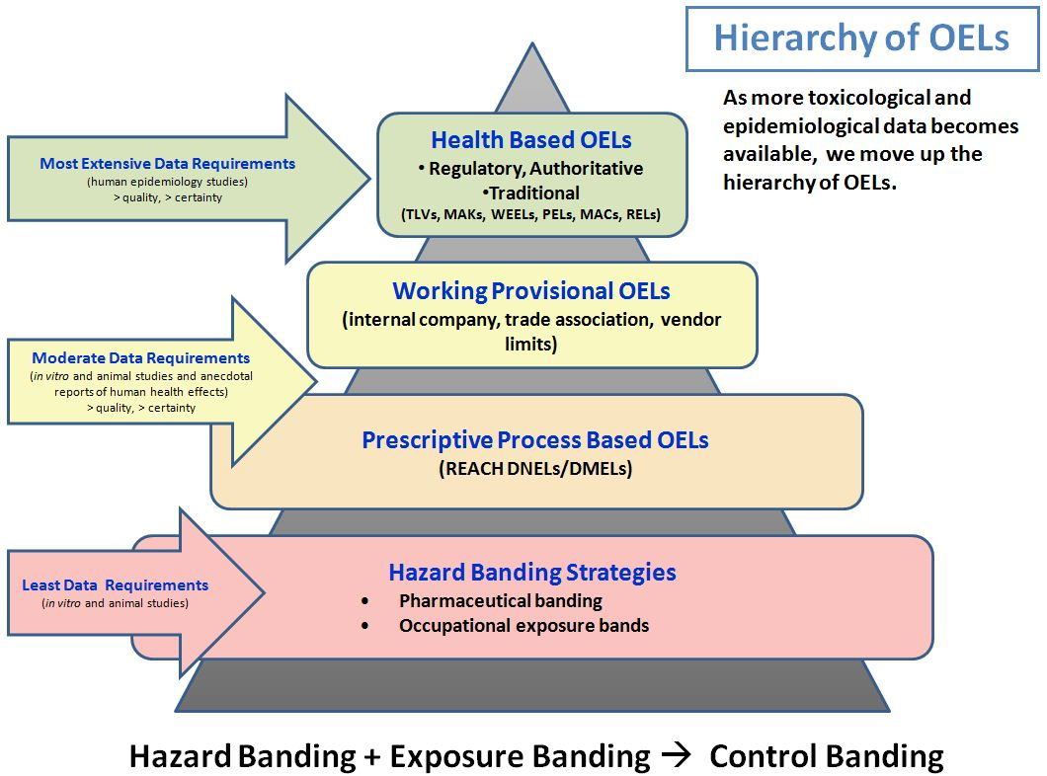

Control Banding
There are many dangerous substances for which there are no formal occupational exposure limits.
In these cases, hazard banding or control banding strategies can be used to ensure worker safety.
Control banding is a qualitative or semi-quantitative risk assessment and management approach.
It is intended to minimize worker exposures to hazardous chemicals and other risk factors in the workplace and to help small businesses by providing and easy-to-understand, practical approach to controlling hazardous exposures in the workplace.

The principle of control banding was first applied to dangerous chemicals, chemical mixtures, and fumes, and emphasizes the controls needed to prevent hazardous substances from causing harm.
The greater the potential for harm, the greater the degree of control needed to manage the situation and make the risk “acceptable.”
A single control technology or strategy is matched with a single band (range of exposures) for a particular class of chemicals (e.g., skin irritants, sensitizers, mutagens).

Band Number Hazard Group Exposure Concentration Control Strategy

1 Skin and eye irritants <1 to 10 mg/m³, or General ventilation and good
>50-500 ppm vapor industrial hygiene practices.

2 Harmful on single exposure >0.1 to 1 mg/m³, or Local exhaust ventilation.
>5 to 550 ppm vapor

3 Severely irritating and >0.01 to 0.1 mg/m³, or Process enclosure.
corrosive <0.5 to 5 ppm

4 Very toxic on single exposure, <0.01 mg/m³, or Seek expert advice.
reproductive hazard, sensitizer <0.5 ppm vapor

Note: Control banding is not without limitations and still requires professional knowledge and experience to verify that the control measures specified have been properly installed, maintained, and used.
Controls should be validated prior to use by either using substance-specific industrial hygiene methods or performing surrogate monitoring.

Hierarchy of Hazard Control
Hierarchy of hazard control is a system used in industry to minimize or eliminate exposure to hazards.
It is a widely accepted system promoted by numerous safety organizations.
This concept is taught to managers in industry, to be promoted as a standard practice in the workplace.
The hazard controls in the hierarchy are, in order of decreasing effectiveness:

• elimination
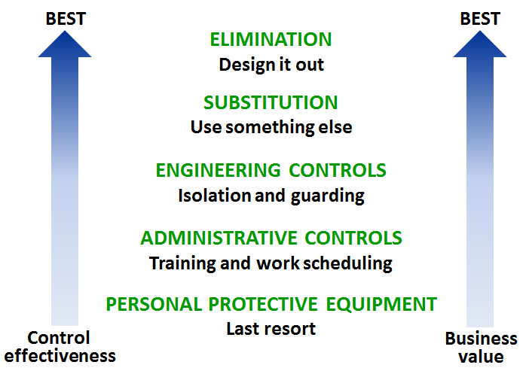

• substitution

• engineering controls

• administrative controls

• personal protective equipment

elimination
Eliminating the hazard – physically removing it – is the most effective hazard control. For example, if employees must work high above the ground, the hazard can be eliminated by moving the piece of equipment they are working on to ground level.

substitution
The second most effective hazard control, substitution, involves replacing something that produces a hazard with something that does not produce a hazard. For example, replacing lead-based paint with acrylic paint accomplishes the same protective outcome, but without exposing workers to lead. To be an effective control, the new product must not produce another hazard.

engineering controls
The third most effective means of controlling hazards is engineering controls. These do not eliminate hazards, but rather isolate workers from the hazard by creating a physical barrier between personnel and hazards. Capital costs of engineered controls tend to be higher than less effective controls in the hierarchy; however, they may reduce future costs. For example, a crew might build a work platform rather than purchase, replace, and maintain fall arrest equipment.

administrative controls
Administrative controls are changes to the way people work. Examples include procedure changes, employee training, and installation of signs and warning labels. Administrative controls do not remove hazards, but limit or prevent worker’s exposure to the hazards. Scheduling road construction so it is performed at night when fewer people are driving is another example.

personal protective equipment
Personal protective equipment (PPE) includes gloves, respirators, hard hats, safety glasses, high-visibility clothing, hearing protection, and safety footwear. PPE is the least effective means of controlling hazards because of the high potential for damage to render PPE ineffective. Additionally, some PPE, such as respirators, increase the physiological effort required to complete a task and, therefore, may require medical examinations to ensure workers can use the PPE without risking their health.

Exposure
A critical determination that must often be made by the health and safety professional is the average exposure to a substance or agent that a worker is subjected to during an 8-hour workday.
The level of exposure (dose) will depend on two factors: the concentration of the substance or agent to which the worker is exposed, and the duration (amount of time) that the worker is exposed.

Types of Occupational Exposure Limits
As seen in the uppermost box on the Hierarchy of OELs diagram, the most rigorously researched Occupational Exposure Limits have been developed by a wide variety of organizations from around the world and adopted by their respective governmental agencies.
Only three of these OELs will be discussed here; however, much information is available regarding the other types of limits.

Threshold Limit Value (TLV)
The Threshold Limit Value (TLV) of a chemical substance is a level to which it is believed a worker can be exposed day after day for a working lifetime without adverse health effects. Strictly speaking, TLV is a term reserved by the American Conference of Governmental Industrial Hygienists (ACGIH). As a non-governmental organization, the TLV is a recommendation by ACGIH with only guideline (non-regulatory) status and should not be confused with exposure limits having a regulatory status.

Recommended Exposure Limit (REL)
The National Institute of Occupational Safety and Health (NIOSH) is the research branch of OSHA, and publishes RELs, which OSHA takes into consideration when promulgating new regulatory exposure limits. Until and unless they are adopted by OSHA, RELs are only recommendations with only guideline (non-regulatory) status.

Permissible Exposure Limit (PEL)
Section 6(a) of the OSH Act granted the Agency the authority to adopt existing Federal standards or national consensus standards as enforceable OSHA standards. Most of the PELs contained in the Z-tables of 29 CFR 1910.1000 were adopted form the Walsh-Healy Public Contracts Act as existing Federal standards for general industry. These, in turn, had been adopted from the 1968 Threshold Limit Values of the American Conference of Governmental Industrial Hygienists. Many OSHA exposure limits are not considered by the industrial hygiene community to be sufficiently protective levels since the toxicological basis for most limits have not been updated since the 1960s.

Part I: Time-Weighted Average (TWA)
PELs are regulatory, and represent the enforceable legal limit in the United States for exposure of a worker to a hazardous substance or agent. However, as noted above, PELs have not been updated for some time. Since TLVs are regularly updated and are generally more restrictive than existing PELs, they represent a known reference that provides greater protection to workers.
Time-weighted averages are expressions on concentrations that have been “time weighted” for the purpose of comparison with 8-hour contaminant concentrations. In other words, if a sample result (always as a concentration) is multiplied by a factor that would make the resultant concentration represent the contaminant level if the sample time had been exactly eight hour, instead of more or less than 8 hours. If sample for exactly 8 hours, the sample result (concentration) is already, by definition, an 8-hour TWA.

Note: Industrial hygienists need to calculate TWAs for all their sample results because OSHA PELs and ACGIH TLVs are expressed as either milligrams per cubic meter (mg/m³) or parts per million (ppm).

TLV-TWA
A TLV is usually given as a time-weighted average that represents the average exposure on the basis of an 8-hour workday and a 40-hour workweek.
A TWA is used to calculate a worker’s daily exposure to a hazardous substance (e.g., chemicals, dusts, fumes, mists, gases, vapors) or agent (e.g., noise), normally averaged to an 8-hour workday.
A TWA is an average using time as the weight and, therefore, takes into account the varying levels of the substance or agent and the amount of time the worker was exposed to each concentration level.
This means that, for limited periods, a worker may be exposed to concentration excursions higher than the TLV, so long as the TWA is not exceeded and any applicable excursion limit (i.e., STEL, C) is not exceeded.

Example: less than 8-hour exposure
If the sampling is less than eight hours (for instance a worker who leaves a contaminated zone to take breaks and eat lunch), it is necessary to “spread out” the concentration into an 8-hour timeframe.
The weight of the contaminant would be unchanged; however, the duration of exposure would fixed at 8 hours (480 minutes).
For example, if the sampling time was 6.5 hours (390 minutes), the TWA calculation would be:

$${concentration in mg}/{m^{3}} • \frac{6.5 hours (390 minutes)}{8.0 hours (480 minutes)}={mg}/{m^{3}} TWA$$

Note: more than 8-hour exposure
If worker exposure is for more than 8 hours (for instance a worker who works 10-hour days), OSHA suggests monitoring for the entire work period, and then using the ‘worst’ 8-hour exposure during the worker’s entire workshift.
The total exposure time (denominator) is fixed at 8 hours (480 minutes).
Currently, the only exception to this interpretation is for lead exposure (29 CFR 1910.1025).

TLV-STEL
Short-term exposure limits (STELs) address spot exposure over a 15-minute period that cannot be repeated more than four times per day with at least 60 minutes between exposure periods.

TLV-C
A ceiling (C) limit is one that may not be exceeded for any period of time, and is applied to irritants and other materials that have immediate effects.

Most often, workers are exposed to varying concentrations of contaminants throughout their shift, as opposed to a steady, uniform concentration.
For this reason, samples are normally collected incrementally (e.g., every 15-minutes or 30-minutes) throughout the shift.
A time-weighted average is equal to the sum of the portion of each time period (as a decimal, such as 0.25 hour) multiplied by the levels of the substance or agent present during the time period, divided by the hours in the workday (usually 8 hrs.).

$$TWA= \frac{C_{a}T_{a}+ C_{b}T_{b}+ . ..C_{n}T_{n}}{8 hrs}$$

where: C_{x} = concentration of contaminant during a specific time period
T_{x} = time of exposure period (in hours)

Example Problem: Water is coming out of a small leak in a pipe. The flow of the leak fluctuates throughout the day depending on the processes that are occurring in the facility. To determine the average amount of leakage during a day, a bucket marked off into one-gallon increments is placed under the leak. At the end of each hour, the bucket is examined to determine how many gallons of water had accumulated. The bucket is then emptied and replaced under the leak. The table below presents the results of this study. Determine the time-weighted average of the water leak.

Time Period Period Duration Volume of Leak

1 1 hr 3 gal
2 1 hr 6 gal
3 1 hr 5 gal
4 1 hr 4 gal
5 1 hr 8 gal
6 1 hr 6 gal
7 1 hr 9 gal
8 1 hr 2 gal

$$TWA= \frac{C_{1}T_{1}+ C_{2}T_{2}+ C_{3}T_{3}+ C_{4}T_{4}+ C_{5}T_{5}+ C_{6}T_{6}+ C_{7}T_{7}+ C_{8}T_{8}}{8 hr}$$

$$TWA= \frac{\left(3gal•1hr\right)+(6gal•1hr)+(5gal•1hr)+(4g•1hr)+(8gal•1hr)+(6gal•1hr)+(9gal•1hr)+(2gal•1hr)}{8 hr}$$

$$TWA= \frac{43 gal hr}{8 hr}$$

$$TWA= 5.375 gal$$

Part II: Mixtures of Contaminants
When two or more hazardous substances that act on the same organ system are present, their combined effect, not the individual effect of either component, should be given primary consideration. In the absence of information to the contrary, the effects of the different hazards should be considered additive.
The formula for additive effects is:

$$\frac{C_{1}}{{TLV}_{1}}+ \frac{C_{2}}{{TLV}_{2}} . . . \frac{C_{n}}{{TLV}_{n}}= ?$$

where: C_{x} = observed atmospheric concentration
TLV_{x} = the TLV that corresponds to the contaminant

Note: If the sum of the fractions is less than one, then the TLV has not been exceeded.
If the sum of the fractions is greater than one, then the TLV has been exceeded.

Example Problem: A worker is exposed to three different airborne contaminants in the workplace. Samples have already been taken and exposure concentrations for each of the three contaminants has been determined. The table below represents the results of these calculations. Determine the combined effect of these simultaneous exposures to determine if the worker exposure has exceeded the TLV.

Observed TLV
Substance Concentration (for substance)

A 15 mg/m³ 85 mg/m³
B 3 mg/m³ 35 mg/m³
C 273 mg/m³ 700 mg/m³

$$\frac{15 mg/m^{3}}{85 mg/m^{3}} + \frac{3 mg/m^{3}}{35 mg/m^{3}} + \frac{273 mg/m^{3}}{700mg/m^{3}} = ?$$

0.18 + 0.09 + 0.39 = 0.66 (the TLV has not been exceeded)

Example Problem: A worker is exposed to four different airborne contaminants in the workplace. Samples have already been taken and the exposure concentrations for each of the four contaminants has been determined. The table below presents the results of these calculations. Determine the combined effect of these simultaneous exposures to determine if the worker exposure has exceeded the TLV.

Observed TLV
Substance Concentration (for substance)

A 45 ppm 225 ppm
B 12 ppm 40 ppm
C 149 ppm 275 ppm
D 62 ppm 75 ppm

$$\frac{45 mg/m^{3}}{225 mg/m^{3}} + \frac{12 mg/m^{3}}{40 mg/m^{3}} + \frac{149 mg/m^{3}}{275 mg/m^{3}} + \frac{62 mg/m^{3}}{75 mg/m^{3}}= ?$$

0.20 + 0.30 + 0.54 + 0.83 = 1.87 (the TLV has been exceeded)

FUNDAMENTALS OF INDUSTRIAL HYGIENE, 6TH ED.

HOMEWORK #1
INDIVIDUAL CALCULATION OF TIME-WEIGHTED AVERAGES

Name:

EXERCISES: Perform the calculations identified below. Show your work neatly and clearly in a manner similar to the examples provided above (i.e., write the formula, define each variable in the formula, show steps of your calculations).

Part I: Duration – Calculation of Time-Weighted Averages
Calculate the 8-hour time-weighted average (TWA) of worker exposure based on the information provided below. (6 points)

Compound: Calcium sulfate (PEL-TWA = 15 mg/m³ (total), 5 mg/m³ (resp), TLV-TWA = 10 mg/m³)

Time Period Contaminant
Period Duration Concentration
(T) (C) (T_{x} • C_{x})

1 0.5 hr 12 mg/m³

2 0.5 hr 9 mg/m³

3 0.5 hr 16 mg/m³

4 0.5 hr 7 mg/m³

5 0.5 hr 5 mg/m³

6 0.5 hr 6 mg/m³

7 0.5 hr 18 mg/m³

8 0.5 hr 23 mg/m³

9 0.5 hr 4 mg/m³

10 0.5 hr 2 mg/m³

11 0.5 hr 6 mg/m³

12 0.5 hr 17 mg/m³

13 0.5 hr 8 mg/m³

14 0.5 hr 3 mg/m³

15 0.5 hr 9 mg/m³

16 0.5 hr 2 mg/m³

Σ = Σ =

Formula: TWA = where: =

=

Calculation: TWA =

TWA =

Carbon tetrachloride is a colorless liquid with a sweet smell that can be detected at low levels. Once widely used as an industrial solvent, a dry-cleaning solvent, and as a refrigerant, its use has been greatly reduced. Carbon tetrachloride is one of the most potent hepatotoxins (toxic to the liver). Prior to the Montreal Protocol, large quantities of carbon tetrachloride were used to produce chlorofluorocarbon refrigerants . . . potent ozone depleting substances. Carbon tetrachloride is also a greenhouse gas. Prior to its use being discontinued, workers employed in a dry-cleaning facility that operated on 8-hour days (40 hours/week) began complaining of light-headedness and dizziness. The company installed ventilation hoods over the tanks of carbon tetrachloride where garments were soaked, and performed air quality monitoring to evaluate the effectiveness of their efforts. The table below provides the results of sampling conducted in the breathing zone of one of its workers.
Calculate the 8-hour time-weighted average (TWA) of worker exposure based on the information provided below to determine if the worker has been exposed above the OEL. (8 points)

Compound: Carbon tetrachloride (PEL-TWA = 10 ppm, TLV-TWA = 5 ppm)

Time Period Contaminant
Period Duration Concentration
(T) (C) (T_{x} • C_{x})

1 15 min 6 ppm

2 20 min 9 ppm

3 15 min 8 ppm

4 45 min 11 ppm

5 35 min 7 ppm

6 20 min 6 ppm

7 40 min 9 ppm

8 20 min 13 ppm

9 30 min 7 ppm

10 25 min 5 ppm

11 15 min 10 ppm

12 20 min 7 ppm

Σ = Σ =

Formula: TWA = where: =

=

Calculation: TWA =

TWA =

Was this worker exposed to this chemical above the PEL-TWA?

Was this worker exposed to this chemical above the TLV-TWA?
Cresols are widely occurring natural and manufactured aromatic organic compounds having a yellowish to brownish red tint, a distinctive “coal tar” aroma, and melting points near room temperature. The name cresol (creosol) reflects their traditional source, creosote. One isomer (m-Cresol) is a precursor to two commercially and widely used pesticides. A worker in the bagging plant for a pesticide manufacturer is exposed to airborne particulates containing cresol. The worker works four 10-hour days each week. An air monitoring device that sampled air in the breathing zone was attached to the worker during a typical work day and produced the results illustrated
Calculate the 8-hour time-weighted average (TWA) of worker exposure based on the information provided below to determine if the worker has been exposed above the OEL. (8 points)

Compound: Cresol (PEL-TWA = 22 mg/m³, TLV-TWA = 20 mg/m³)

Time Period Contaminant
Period Duration Concentration
(T) (C) (T_{x} • C_{x})

1 40 min 17 mg/m³

2 45 min 21 mg/m³

3 35 min 29 mg/m³

4 35 min 17 mg/m³

5 25 min 25 mg/m³

6 15 min 21 mg/m³

7 35 min 24 mg/m³

8 45 min 23 mg/m³

9 30 min 15 mg/m³

10 35 min 19 mg/m³

11 30 min 26 mg/m³

12 25 min 17 mg/m³

13 35 min 13 mg/m³

14 40 min 24 mg/m³

15 25 min 25 mg/m³

16 20 min 13 mg/m³

17 30 min 12 mg/m³

Σ = Σ =

Formula: where: =

=
Calculation:

Was this worker exposed to this chemical above the PEL-TWA?

Was this worker exposed to this chemical above the TLV-TWA?

Part II: Exposure to Mixtures
Cosmetics and fragrances contain many chemical compounds that are known to have detrimental health effects. While concentrations are typically quite low in the final commercial product, in the factories where these compounds are stored and mixed, concentrations may be far higher. A worker in a blending room was exposed to multiple chemical airborne contaminants simultaneously. Fortunately, the worker was wearing an air-sampling device, so there is a record of the exposure concentrations for each contaminant. The table below represents these results.
Perform the required calculations using the ACGIH TLV-TWA values to determine the combined effect so you will know if the worker was exposed above the TLV. (5 points)

Chemical Chemical OEL Exposure
Compound Function (PEL, TLV) Concentration

diethyl phthalate (DEP) Solvent used to bind PEL-TWA (none) 0.4 mg/m³
cosmetics and fragrances. TLV-TWA (5 mg/m³)

1,4-Dioxane A carcinogenic contaminant PEL-TWA (360 mg/m³) 14 mg/m³
of cosmetics. TLV-TWA (72 mg/m³)

diethanolamine (DEA) Used in cosmetics to adjust PEL-TWA (none) 0.6 mg/m³
pH. TLV-TWA (2 mg/m³)

triethanolamine (TEA) Ionic surfactant. PEL-TWA (none) 1.4 mg/m³
TLV-TWA 5 (mg/m³)

Formula:

where: =

=

Calculations:

Was the worker’s exposure greater than the TLV?

During painting operations, keeping oil-based paints the proper consistency is often accomplished through the addition of a thinning liquid. There are a variety of paint thinners, each utilizing a different mixture of solvents. During the mixing process and during application, particularly when an air applicator is used, there is the potential for workers to be exposed to vapors. A worker uses a combination of three different paint thinning agents; naphthalene, dimethylformamide (DMK), and ethylbenzene. The worker then applies the paint using a pneumatic spray gun inside a room that has been closed off from adjoining rooms by plastic sheets to prevent overspray and migration of odors, as well as to keep dust from entering the room. The observed concentrations of each thinning agent are identified in the table below.

Access the chemical sampling database on the OSHA website:
https://www.osha.gov/dts/chemicalsampling/toc/toc_chemsamp.html

Click on the “Index of Chemical Sampling Information”
Use the alphabetical buttons across the top of the page to find the chemical sampling information for each of the chemicals identified above: Naphthalene, Dimethylformamide (DMK), and Ethylbenzene.
When you have accessed each page, record the PEL-TWA (in ppm) for each compound and record it in the table below. (3 points)

Observed PEL-TWA
Substance Concentration (for substance)

Naphthalene 2 ppm

Dimethylformamide 3 ppm

Ethylbenzene 62 ppm

Perform the required calculations using the OSHA PEL-TWA values to determine the combined effect so you will know if the worker was exposed above the PEL. (5 points)

Formula:

where: =

=

Calculations:

Was the worker’s exposure greater than the PEL?

