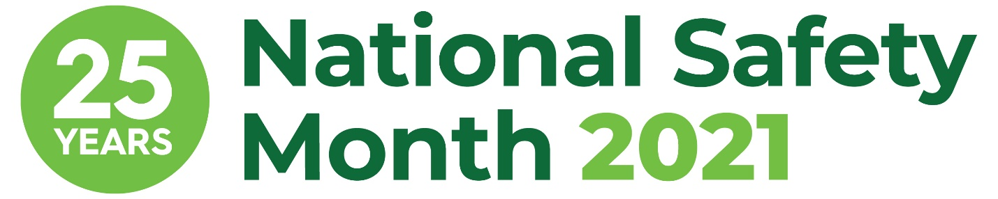

NSM Week 4 Sample Email Copy

[Subject] Join [COMPANY NAME] this June for National Safety Month

[Body]
Hello [NAME],
I am proud to share that [COMPANY NAME] is taking part in the 25th anniversary of National Safety Month, taking place throughout June 2021. This annual observance, led by the National Safety Council, highlights pressing weekly topics and encourages everyone to prioritize safety from the workplace to anyplace.

The fourth week of June will focus on advancing your safety journey. Safety is all about continuous improvement, building on our successes and constantly learning so we can make it home safe at the end of the day. We all play a role in this journey, from staying aware of the biggest risks and reporting hazards to making every decision with safety in mind.
At [COMPANY NAME], we believe continuous improvement is crucial to a safe workplace. [COMPANY NAME] is excited to participate in this important observance by [SHARE DETAILS ON HOW YOU ARE PARTICIPATING].
Please join us in prioritizing safety at work so we can all continue on this journey. Visit nsc.org/nsm to learn more about National Safety Month.
Sincerely,
[YOUR NAME AND COMPANY SIGNATURE BLOCK]

