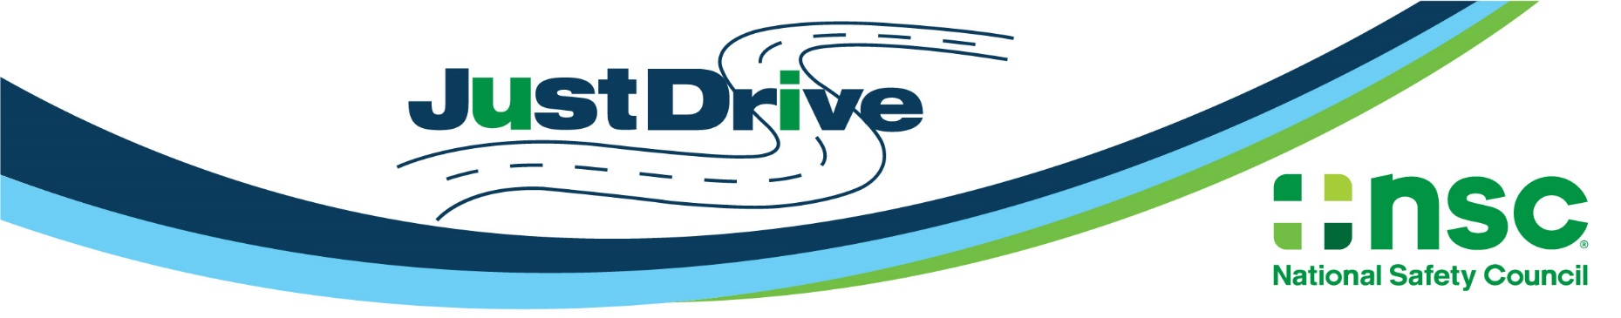

Distracted Driving Awareness Month Social Media Kit
Social Media Kit Instructions:
- Download images from their boxes.
- You may use the post suggestions provided or simply use them as inspiration to create your own posts.
- Always include the #JustDrive hashtag. This ensures we’ll all be part of the same social conversation!
- Be sure to tag the National Safety Council in your posts. Type out and select ‘@National Safety Council’ in Facebook and LinkedIn posts for proper tagging.
- You can also share messages from the NSC social media pages by clicking ‘share’ in each platform. We’ll be sharing additional posts throughout the month of April.
  - Facebook
  - LinkedIn
  - Twitter
  - Instagram
Questions? Contact Al.Lagattolla@nsc.org.

Images | Facebook/LinkedIn Post | Twitter Post
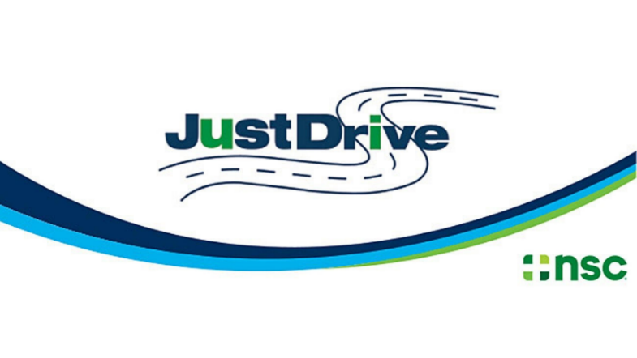 | This April for Distracted Driving Awareness Month, help make our roads safer for us all and take the @National Safety Council #JustDrive Pledge to drive distraction-free: nsc.org/pledge | This April for Distracted Driving Awareness Month, help make our roads safer for us all and take the @NSCsafety #JustDrive Pledge to drive distraction-free: nsc.org/pledge
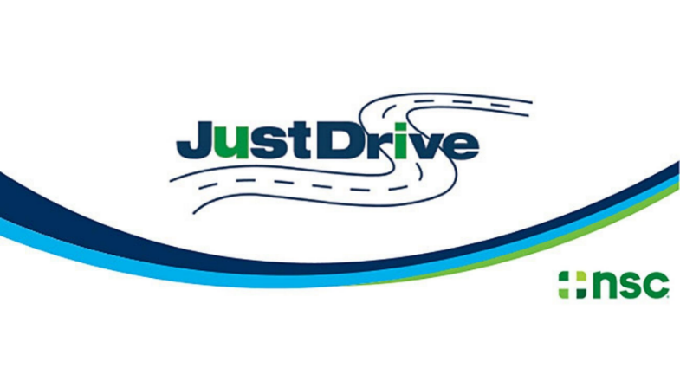 | Our roads are the most dangerous they’ve been in years, but your support can make a difference. This Distracted Driving Awareness Month, make a donation to the lifesaving mission of the @National Safety Council: http://bit.ly/JustDriveDonate  #JustDrive | Our roads are the most dangerous they’ve been in years, but your support can make a difference. This Distracted Driving Awareness Month, make a donation to the lifesaving mission of @NSCsafety: http://bit.ly/JustDriveDonate  #JustDrive
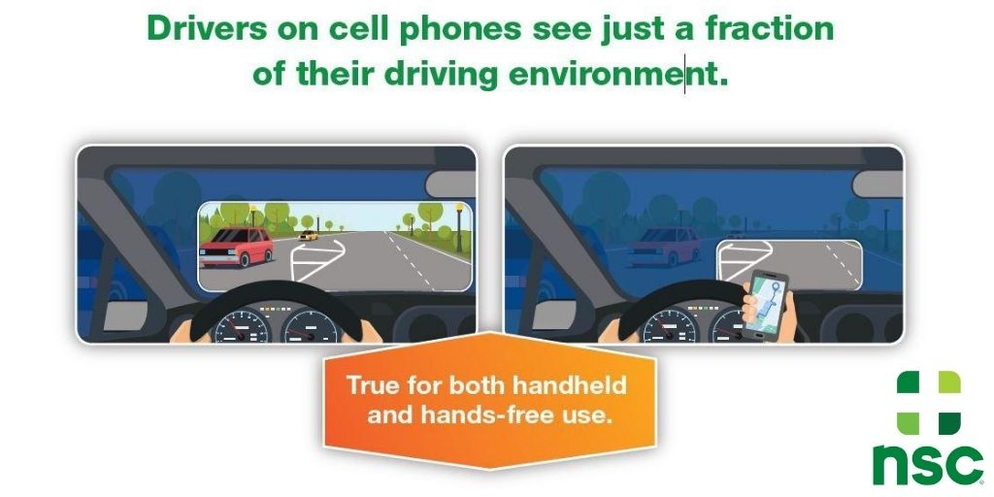 | At 55 mph, a 4-second text takes your eyes off the road while you travel the full length of a football field! Distracted driving can be deadly. #JustDrive and get free @National Safety Council resources at https://bit.ly/nscddam2022 | At 55 mph, a 4-second text takes your eyes off the road for the length of a football field! Distracted driving can be deadly. #JustDrive and get free @NSCsafety resources at https://bit.ly/nscddam2022
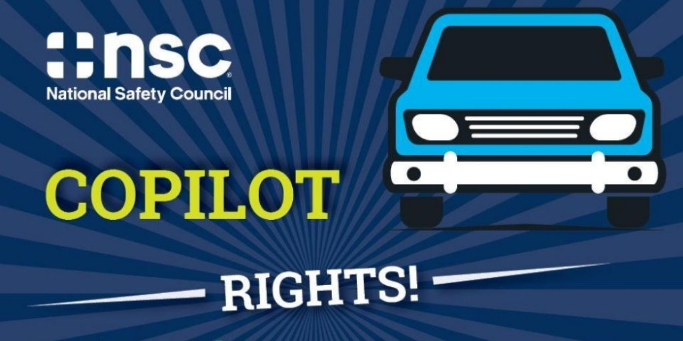 | Riding as a passenger? If your driver is distracted or doing something dangerous, you have the right to speak up! Get @National Safety Council tips for having this discussion and staying safe in every seat in the car: https://bit.ly/nscddam2022 #JustDrive | When you’re a passenger, you have the right to speak up if your driver is distracted or doing anything dangerous. Get @NSCsafety tips and free resources to #JustDrive: https://bit.ly/nscddam2022
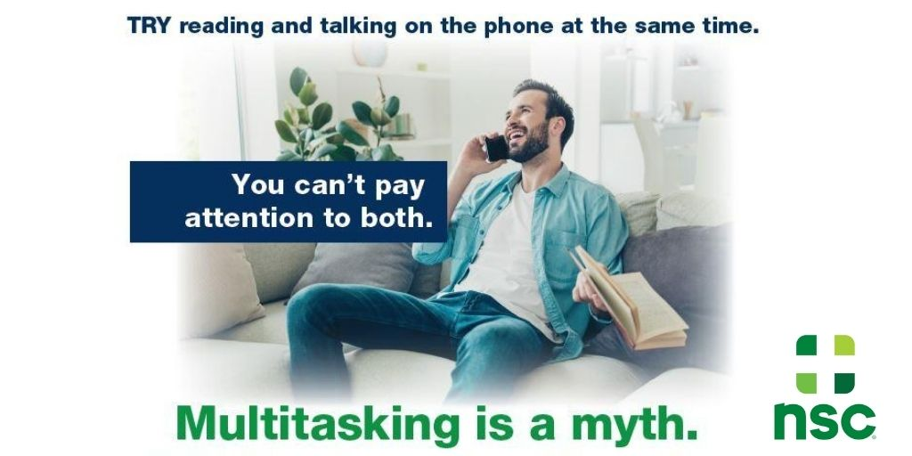 | It’s not about skill; multitasking is a myth. When you’re behind the wheel, put your phone away and #JustDrive. Spread the word with free @National Safety Council resources for Distracted Driving Awareness Month: https://bit.ly/nscddam2022 | It’s not about skill; multitasking is a myth. When you’re behind the wheel, put your phone away and #JustDrive. Spread the word with free @NSCsafety resources for Distracted Driving Awareness Month: https://bit.ly/nscddam2022
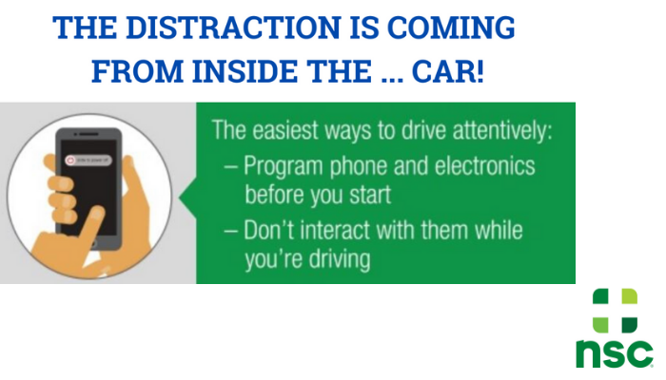 | A dangerous distraction is coming from inside your own car – your cell phone! Set up your playlist, podcast or GPS when you first get in your car, then #JustDrive. Get free @National Safety Council Distracted Driving Awareness Month resources: https://bit.ly/nscddam2022 | A dangerous distraction is coming from inside your own car – your cell phone! Set up your playlist, podcast or GPS when you first get in your car, then #JustDrive. Get free @NSCsafety Distracted Driving Awareness Month resources: https://bit.ly/nscddam2022

Videos To Share | Facebook/LinkedIn Post | Twitter Post
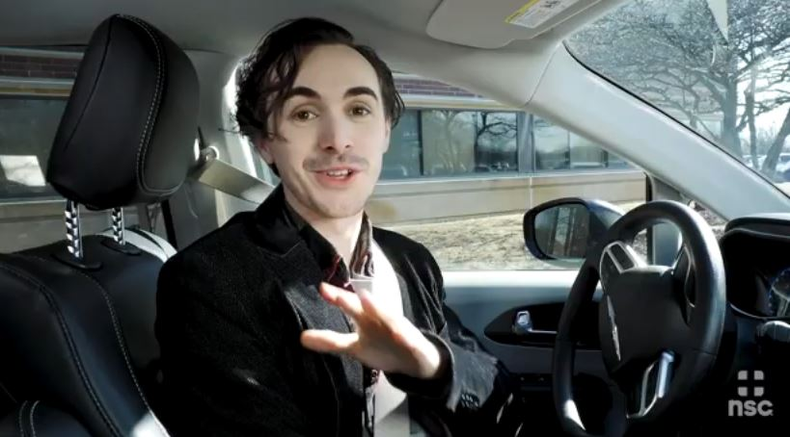  “Hot to Set Up Your Drive” Video  Copy and paste this link in your social post: https://www.youtube.com/watch?v=FudGI56Bm4M | It only takes a few seconds to set up your drive and avoid distractions. Check out how simple it is to #JustDrive and get free @National Safety Council tools to help: https://bit.ly/nscddam2022 | It only takes a few seconds to set up your drive and avoid distractions. Check out how simple it is to #JustDrive and get free @NSCsafety tools to help: https://bit.ly/nscddam2022
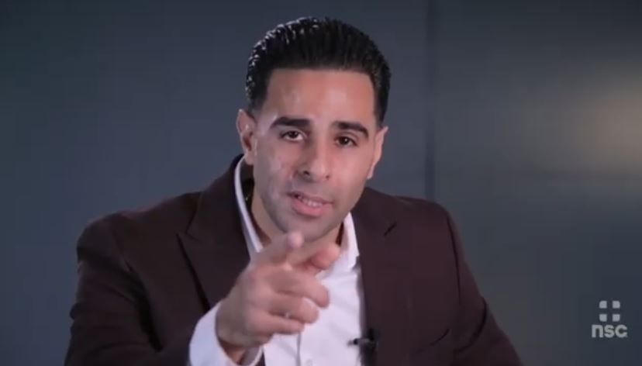  “Distracted Driving: State Trooper Shares His Story” Video  Copy and paste this link in your social post: https://www.youtube.com/watch?v=vg7ljIalbhU&t=118s | “I’m on fire to educate people, to let them know: Put it down. Don’t use your phone while you drive.”  A distracted driver almost killed Carlos Rosario, a Florida highway patrolman. Help keep everyone on the road safe and #JustDrive. Learn more from the @National Safety Council: https://bit.ly/nscddam2022 | “I’m on fire to educate people, to let them know: Put it down. Don’t use your phone while you drive.”  A distracted driver almost killed Carlos Rosario, a Florida highway patrolman. Help keep everyone safe and #JustDrive. Learn more from @NSCsafety: https://bit.ly/nscddam2022

